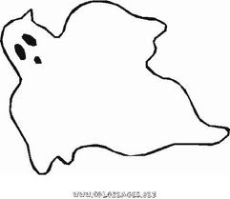
Witches, witches,skeleton and bat,
scary ghosts and big black cat,
booh booh booh ! what a fright!
It's scary scary,
on the halloween night !

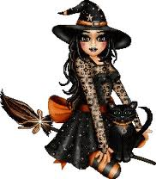
We wish you a scary Halloween

